Final summaries

**How do health outcomes differ by demographic factors such as race and sex?**

Hispanic participants had the lowest morbidity and multimorbidity of weight-related illnesses. Black participants more frequently had diabetes, lung/respiratory problems, and obesity, whereas White participants had higher cholesterol and heart disease.

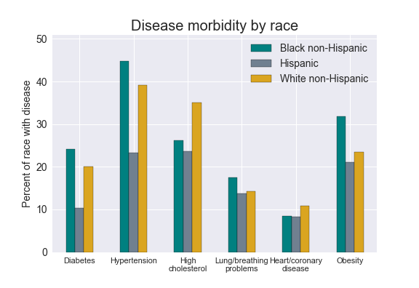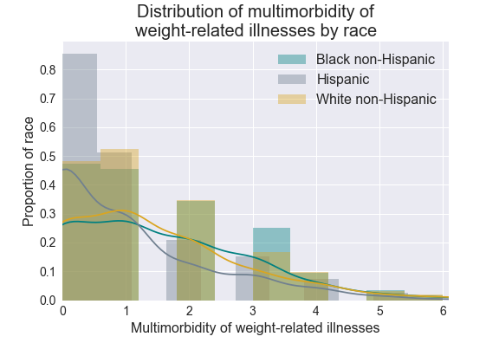

All groups had overweight BMIs, on average. Hispanic and White participants had comparable BMIs while Black participants had higher BMIs.

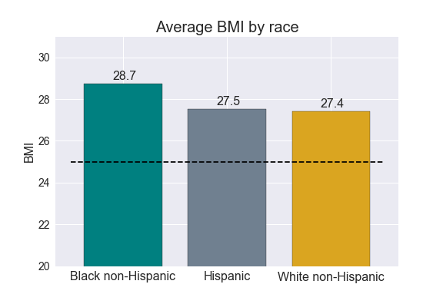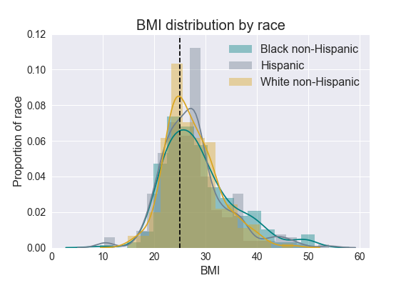

**How do health outcomes vary among individuals with differing access to supermarkets?**

At the individual level, adults who could not afford fruits and vegetables tended to have higher BMIs than those who could afford fruits and vegetables.

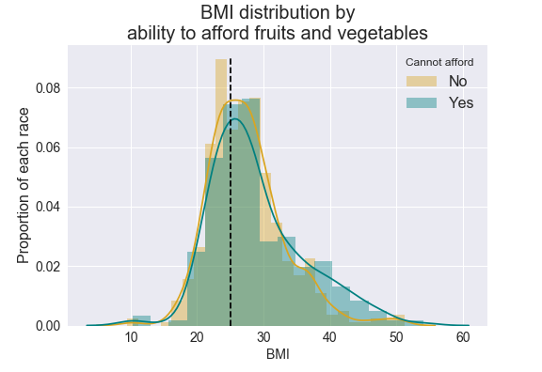

This is supported by our findings using Census data. Surprisingly, clustering was found with obesity and food scarcity as a health outcome, so while there is an observable relationship between obesity and our measure of scarcity, it’s not a very strong relationship.

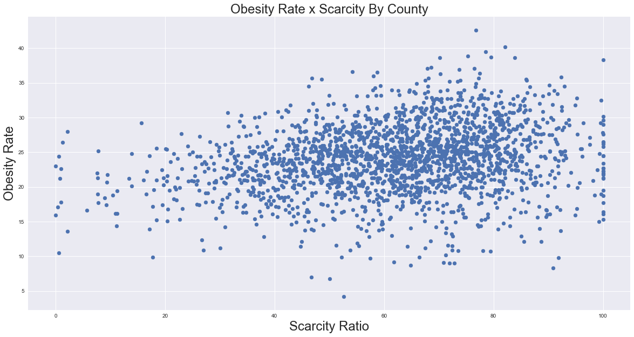

Also, food scarcity seemed to better be tracked by population density than any further subgroupings, though we suspect that is from the ‘over 1 mile from supermarket’ definition we used.

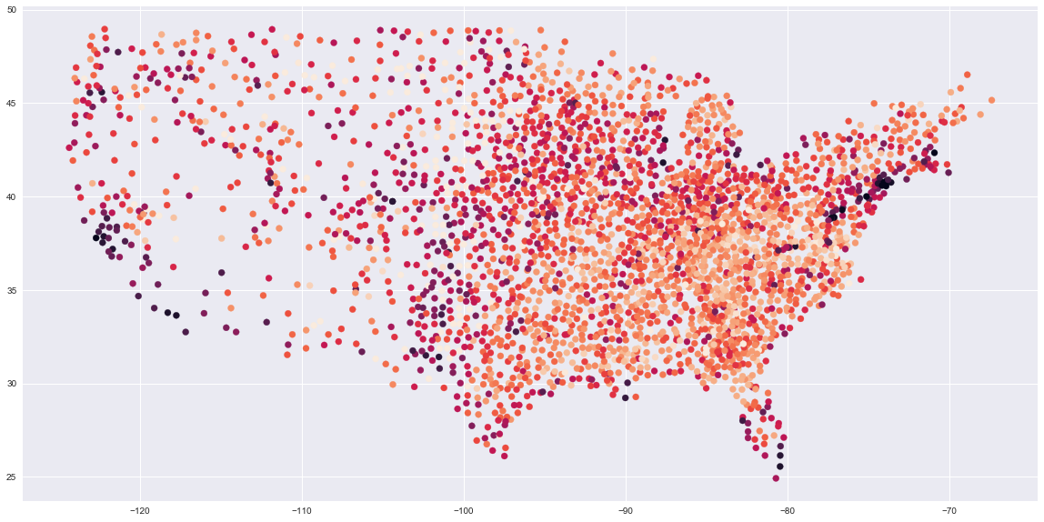

We further investigated whether food scarcity differed among different racial groups. The individual survey data showed that access was lowest among Hispanic adults.

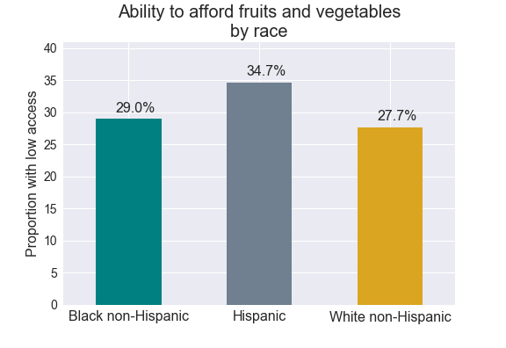

However, using Census data, food scarcity by location was higher among all white people over all communities looked at, followed by African American, and Hispanics had the least occurrence of food scarcity in the larger population. This was surprising as it was counter-intuitive to initial expectations/assumptions we’d made.

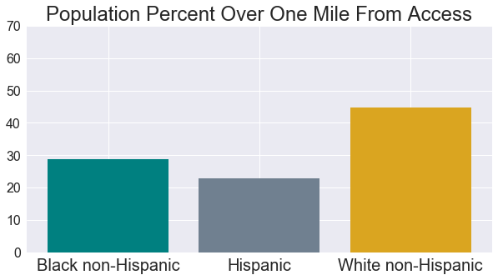

These contrasting findings could be because Census data measured access as proximity to supermarkets whereas the Healthy Americas individual-level data measured affordability. It’s certainly possible that some people who live very close to supermarkets may not be able to afford fruits and vegetables.